First order LP
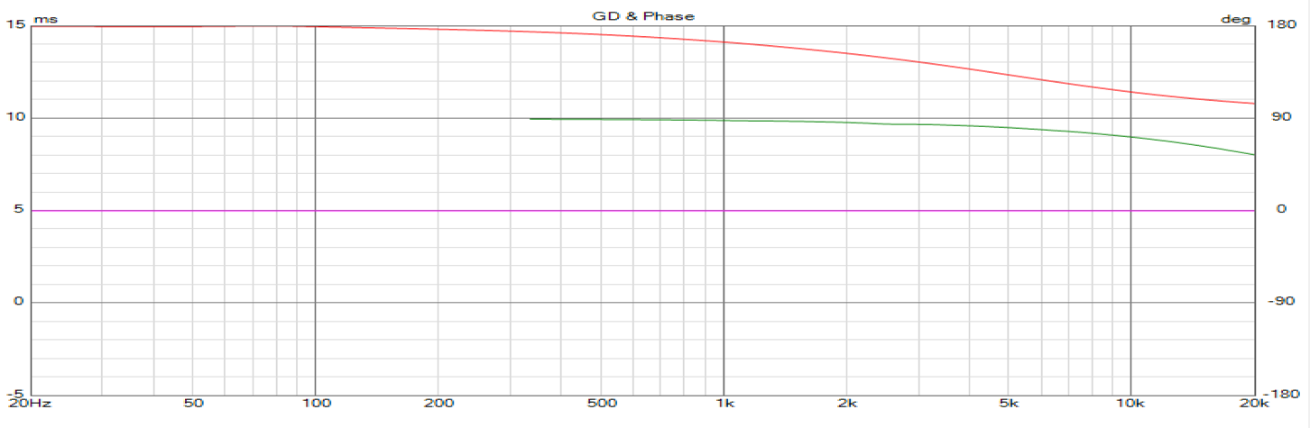

Weems notch (as LP)
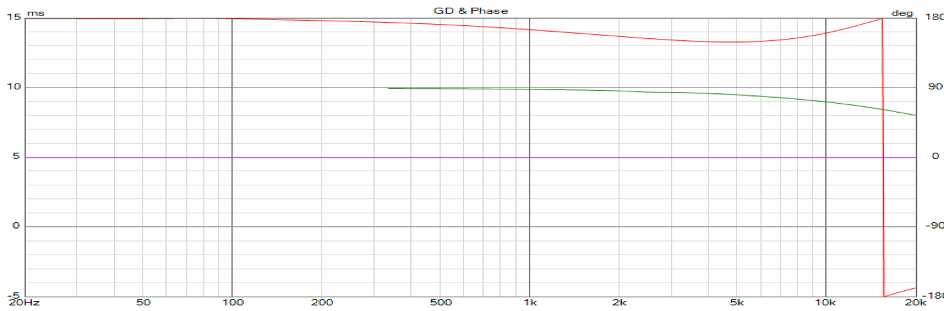

2nd order LP
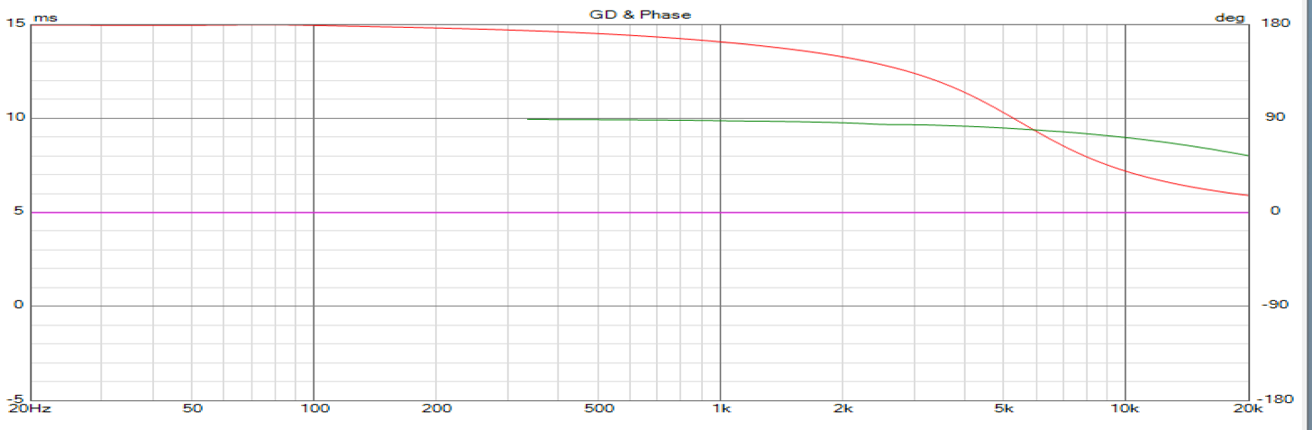

2nd order w parallel resistor
