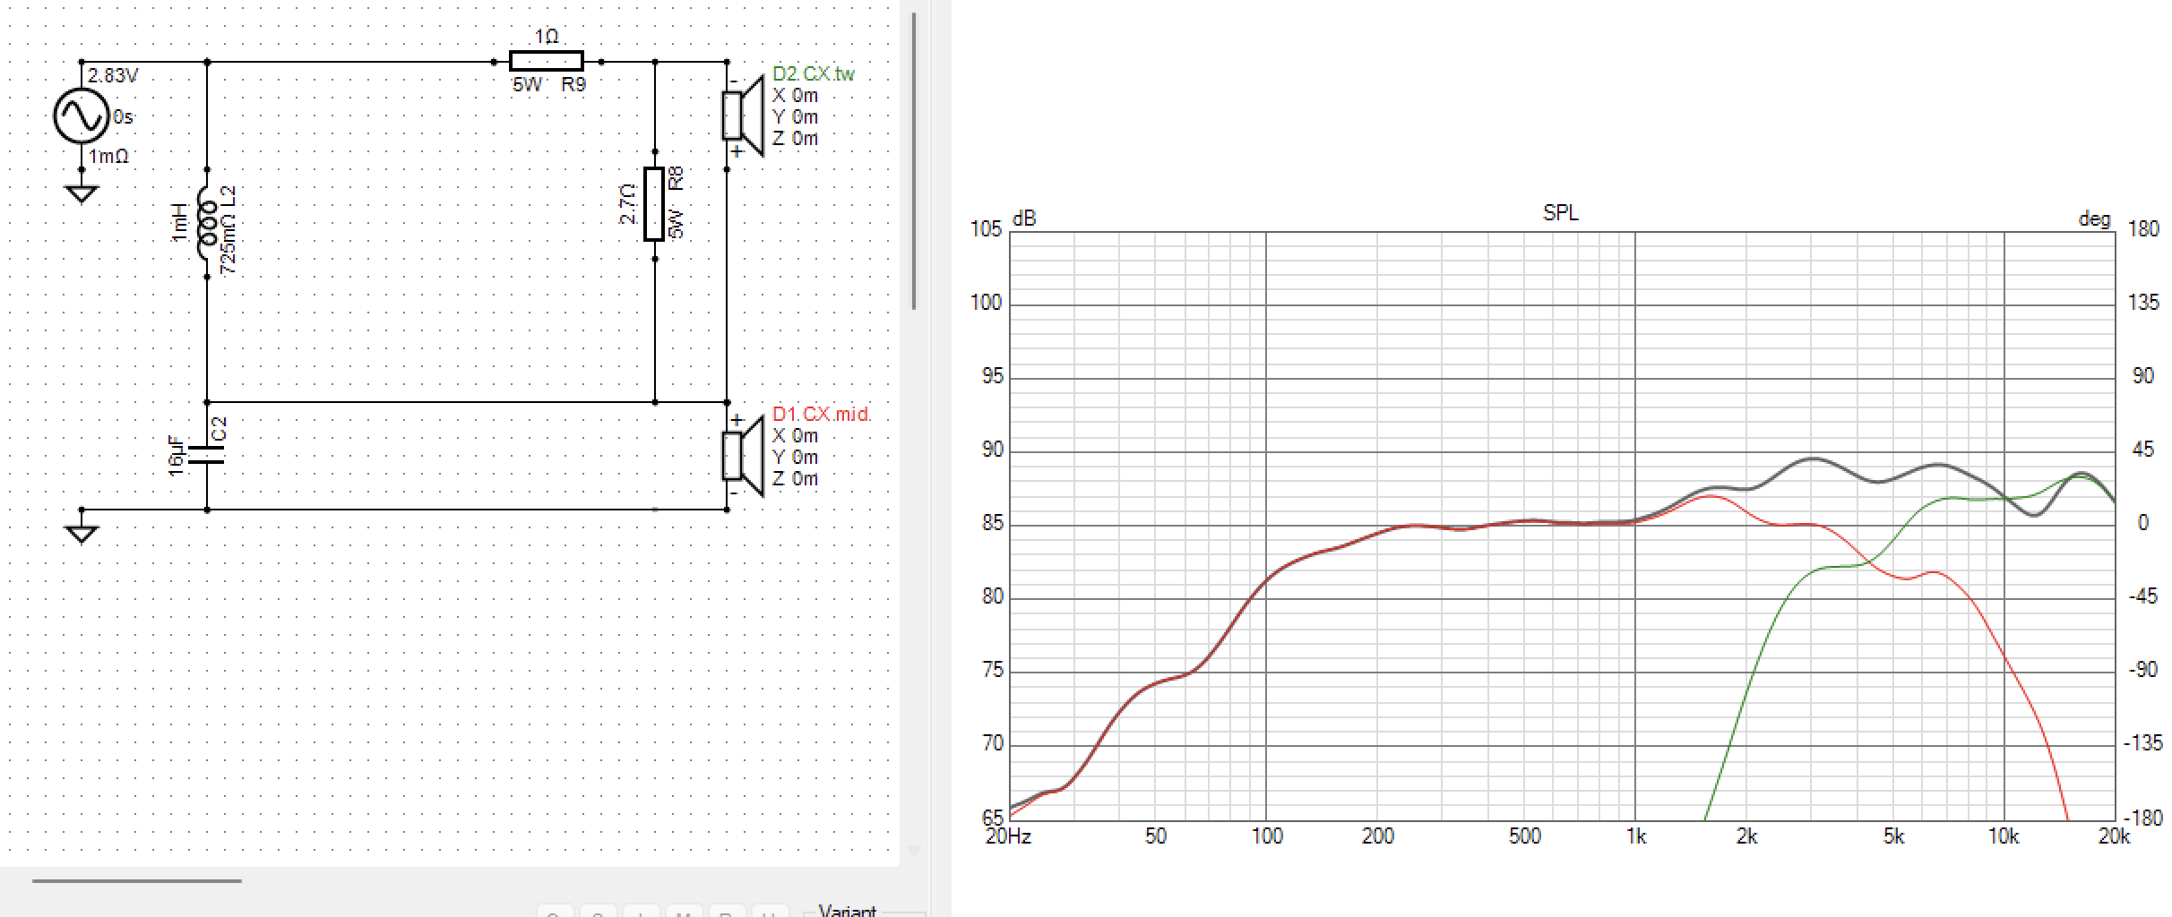
-------------------------------------------------------------------------------------------------------------------------------

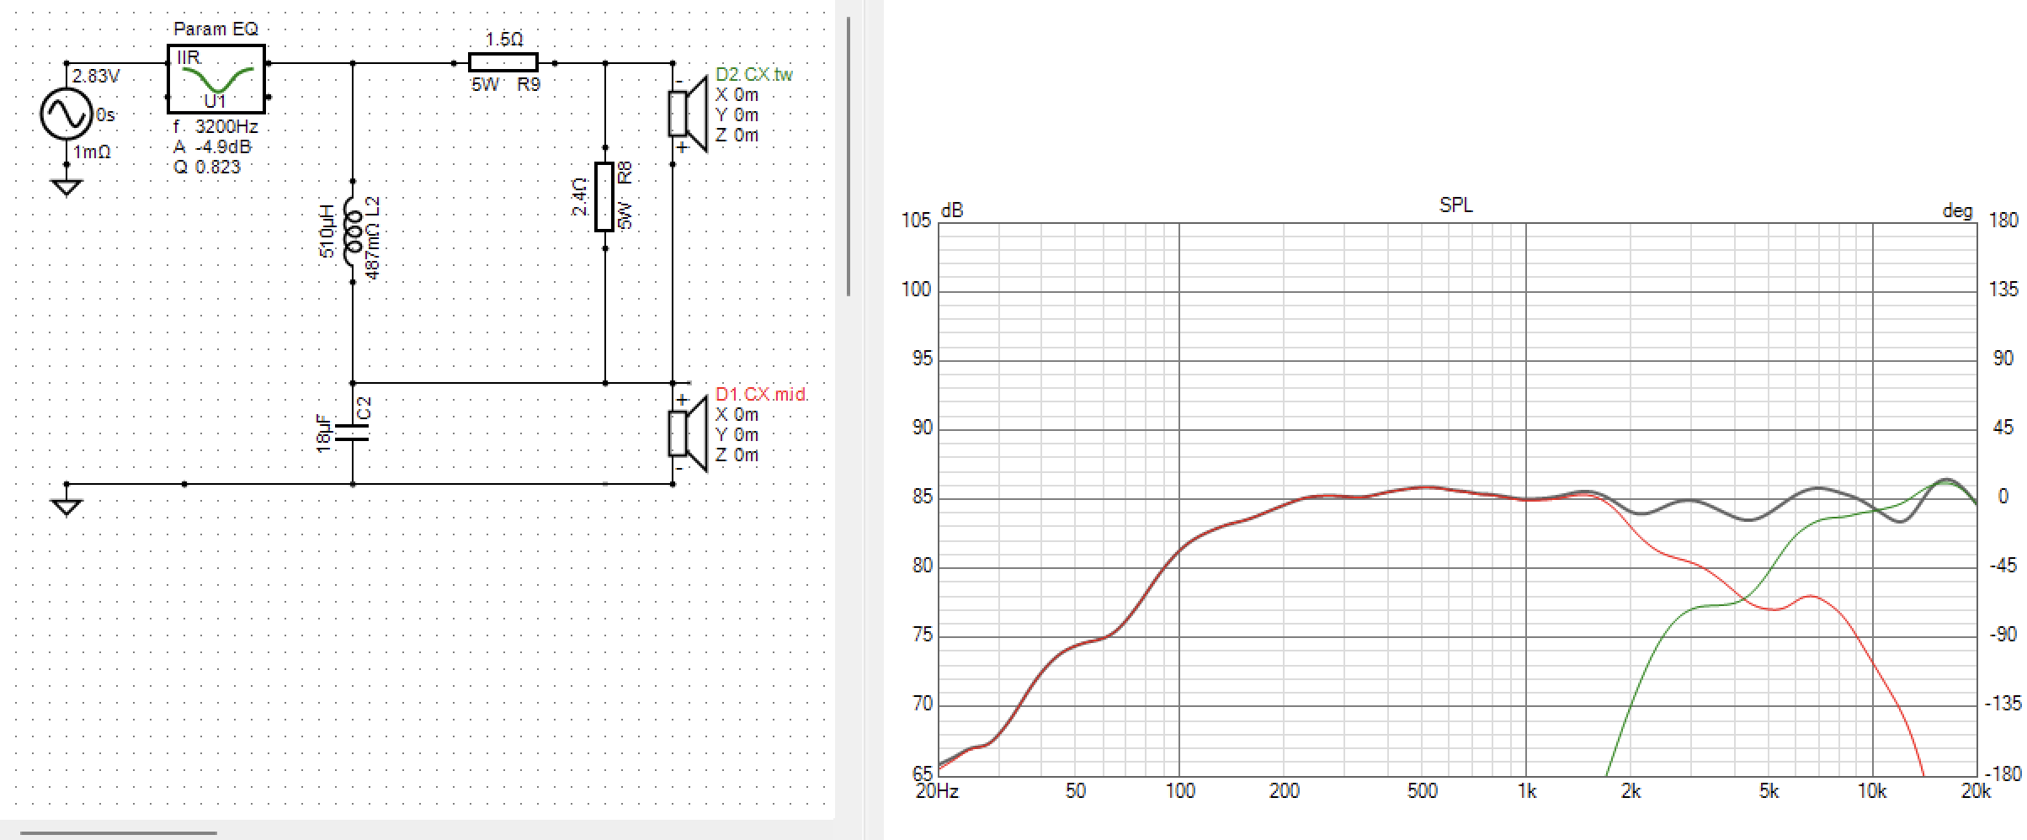

_____________________________________________________________________________
Celestion’s suggested crossover design

